Print Each Element:

Given numbers = [1, 2, 3, 4, 5], use a for loop to print each number.

Print List Elements with Text:

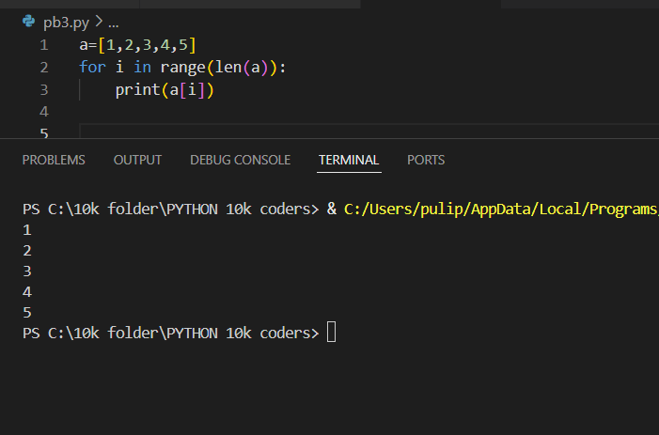

Given fruits = ["apple", "banana", "cherry"], use a for loop to print:

I like apple

I like banana

I like cherry

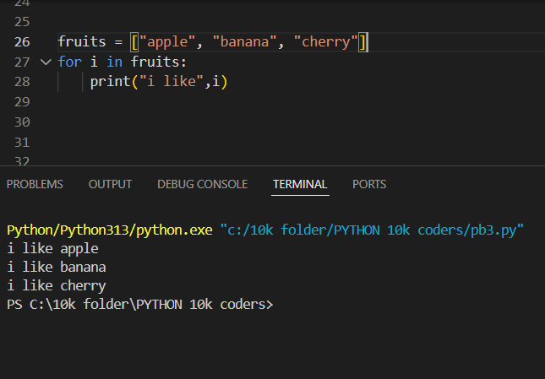

Sum of List Elements:

Given nums = [10, 20, 30, 40], use a for loop to calculate and print the total sum.

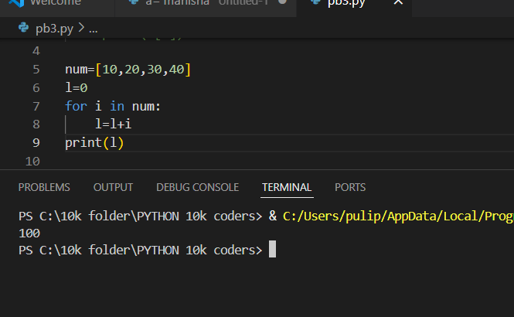

Count Even Numbers:

Given numbers = [1, 2, 3, 4, 5, 6], use a for loop to count how many numbers are even.

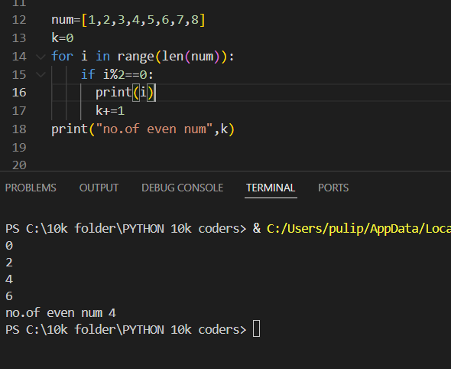

Find the Largest Number:

Given nums = [3, 7, 2, 8, 5], use a for loop to find and print the largest number.

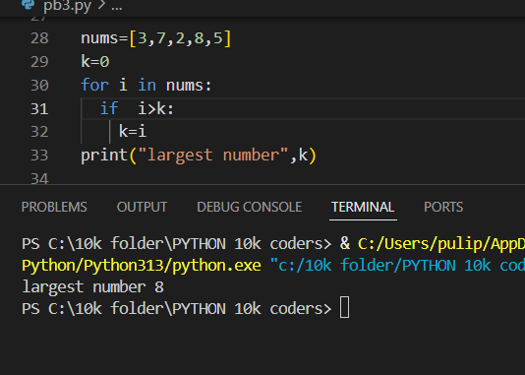

Given original = [5, 10, 15, 20], use a for loop to copy all elements into a new list.

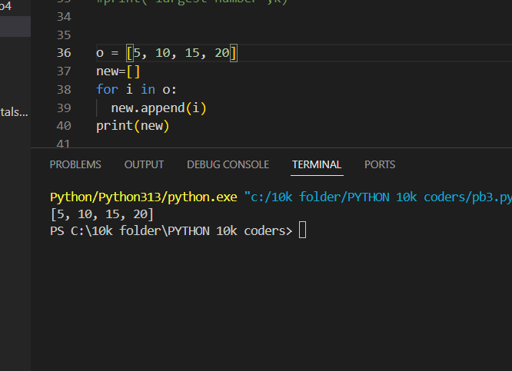

Multiply Each Element by 2:

given nums = [1, 2, 3, 4], use a for loop to create a new list where each number is doubled.

Reverse a List (Using Loop)

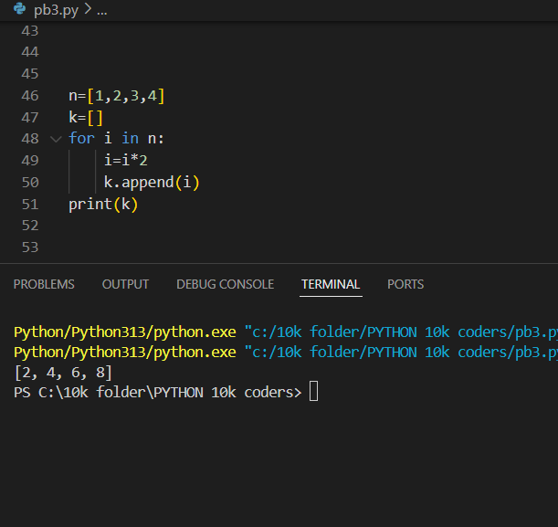

Given words = ["hello", "world", "python"], use a for loop to print the elements in reverse order.

Find Words Starting with 'A':

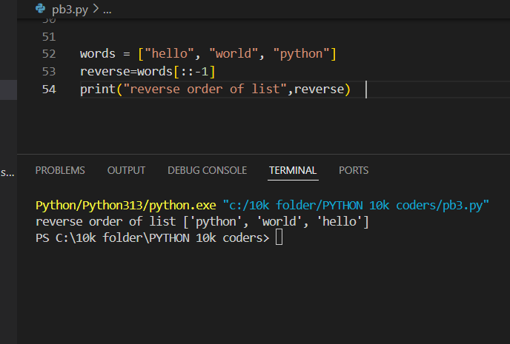

Given words = ["apple", "banana", "avocado", "grape"], use a for loop to print only the words that start with "a".

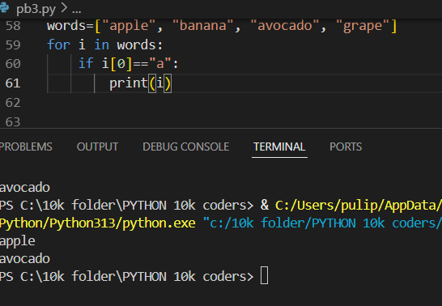

Create a New List with Only Positive Numbers:

Given numbers = [-5, 10, -3, 7, -2, 8], use a for loop to create a new list containing only the positive numbers.

